Applied Sciences & Engineering Technology/
Environmental Applied Science and Technology
140 Weymouth Street
Charlottetown
Canada C1A 4Z1
E-mail: lmaceachern@hollandcollege.com

May 31, 2021

Dear Student

Welcome!

Congratulations on your acceptance into the Environmental Applied Science Technology (EAST) Program at Holland College! We recognize this is an exciting and important step for you towards your future career. We are looking forward to meeting and working with you as you start this incredible and rewarding journey towards attaining your goals.

As you will appreciate, this upcoming educational year may be unique. During the year, a blended learning approach will need to be used, with the focus on providing as much hands on and active learning as we can safely accommodate. Mixed in will also be some virtual and distant learning mixed in.

Please feel free to contact me with any questions which I will clarify as much as possible on what you can expect and how best to prepare. Also, please email me at the email below to confirm you received this email. This will help verify we have your correct contact information, and you are receiving future emails from us.

Instructor Contact Information: Bryan Grimmelt (1st Year Learning Manager)
bkgrimmelt@hollandcollege.com (902) 629-4216
Room 328 Center for Applied Sciences Technology
Working Ahead Opportunity: July 2021
One of the required courses (for all Holland College students) is Computer Essentials which is also part of your first year. This summer there is an opportunity to take this course during the summer starting on July 5. By completing this it would take this course off of your course load during the Fall Term.

IMPORTANT DATES:

Wed Sep 1, 2021: First day of classes for first year students/ Orientation
Thu Sep 2: CPR/First Aid Day 1 for Environmental Science Students
Fri Sep 3: CPR/First Aid Day 2 for Environmental Science Students

(CPR/First Aid are 2 day required courses for all Holland College Students. The 2 days scheduled above are designated for first year environmental science students)

Other Notable Dates
Mon Sep 6: No classes Labour Day
Mon Oct 11: No classes Thanksgiving
Thur Nov 11: No classes Remembrance Day
December 11, 2021 Last Day of Class before Christmas
January 6, 2022 First Day of Class (Winter Semester)
Feb 22-26, 2022 February Break No classes
April 22, 2022 Last Day of Classes (Winter Semester)

Plans for Program Delivery in September 2021

The plans, which have been developed in consultation with the Chief Public Health Office of Prince Edward Island, are based on provincial and national best practices and will be monitored and adjusted in consultation with the Chief Public Health Office if necessary.
Holland College students will be back on campuses and in centres across the Island full time in September, with extensive COVID-19 protocols in place.
Students will be divided into cohorts of up to 50 people including faculty, however most class sizes are significantly smaller. Interactions between cohorts will be minimized through scheduling and dedicated space assignments where possible. In addition to face-to-face delivery, some programs will offer opportunities for blended or technology-enhanced learning in some courses.
The plan is centered on the health and safety of our students, staff, and individuals who have been approved to be on site. Since the beginning of this school year, Holland College staff and students have demonstrated their sense of social responsibility by respecting and adhering to our COVID-19 guidelines in order to protect themselves and others. I am sure that this will continue in September as we adjust to the “new normal” for a little longer.

ENVIRONMENTAL SCIENCE FIRST YEAR FIRST TERM CLASSES AND Text-Books

TEXT BOOKS: Your main textbooks this year will be available as e-books. There is no requirement to purchase the actual physical copies (which are more expensive), although this is also an option.
_______________________________________________________________________________
First Term: E-Texts with On-line Essential Software

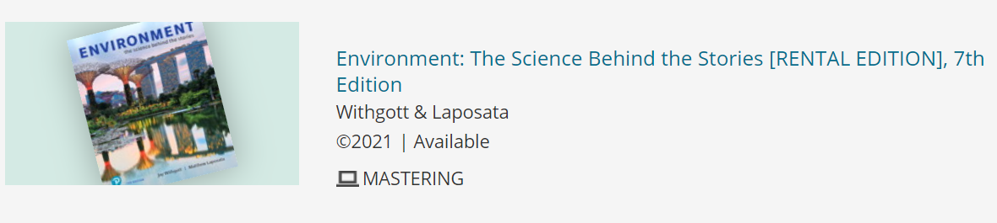
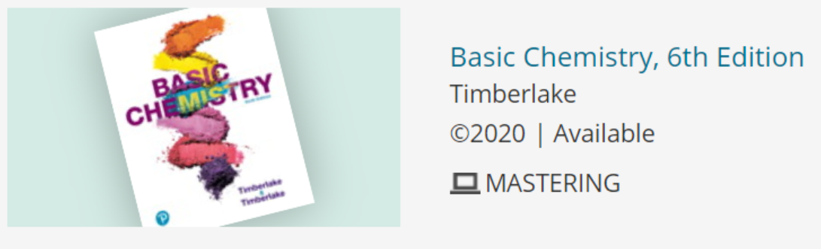
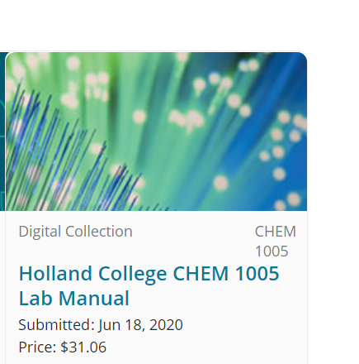
Customized Laboratory Manual for Environmenta l Chemistry CHEM 1005.

_______________________________________________________________________________
Second Term E-Text with On-line Mastering Software
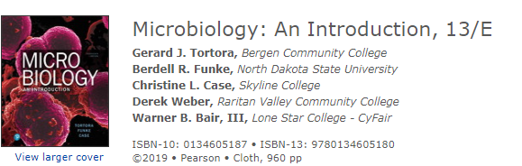

The above e-books all come with access codes for the on-line resources that you will be needing for completing your courses.

Textbook and access codes for Natural Science Math:
Textbook:
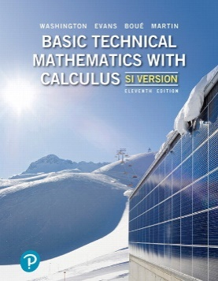
Basic Technical Mathematics with Calculus, SI Version, Eleventh Edition, 11/E
Allyn J Washington, Michelle Boué, Richard Evans, Elizabeth Fabbroni Martin
ISBN-10: 0135309476
ISBN-13: 9780135309476
Publisher: Pearson Education Canada
Copyright: 2020
Note on Math Textbook: Available in both hard bound and e-text (pdf). I will not require one over the other. The bookstore will have a limited supply of hard copies. Keep in mind that students are permitted to use their text during the final exam, but electronic devices are not be permitted. I do have a classroom supply of older editions that student may use in class during the final exam if they only have the e-edition.

Computer Essentials:

Custom Text with MyLab It Pearson E-Text Access Card. MyLab It Pearson E-Text Access Card only for those who do not want the hard copy custom text.

There are also two Handbooks that physical copies should be purchased.
These handbooks may be purchased second hand.
Freshwater Invertebrates of North America
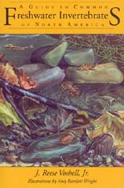
This book is used for Ecology and Biology components of Environmental Science including assessing Environmental Health of Freshwater systems. Used early in the first term and as a resource through the duration of the program. This book may be purchased second hand. On-line access codes are not necessary

RECOMMENDED HANDBOOK For Map Use and Analysis

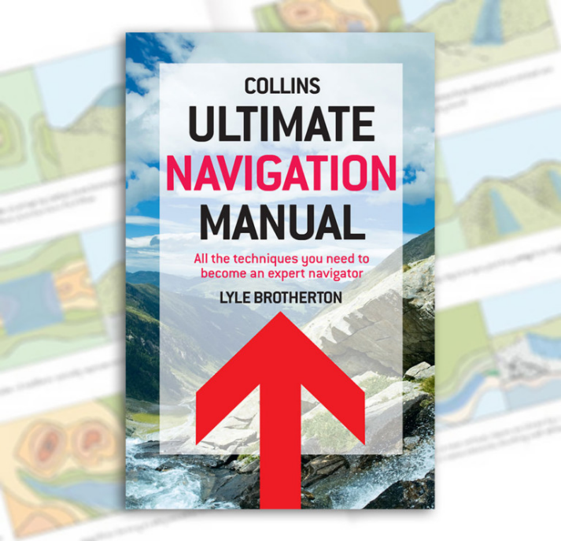

Location of Classrooms: 1st Year Students: Room 328, CAST Building,
Prince of Wales Campus

Required Materials: There are lab and field activities that require special clothing. This includes a lab coat (which we will supply for you). You will also need to purchase suitable gear for the field work, including chest waders and rubber boots. More information on obtaining these items will be sent out.

It is suggested that you also own a good rain suit and rubber boots for the course field work and a pair of CSA safety-rated work boots, which are required as per OHS Act Regulations for entrance to some industrial sites.

From Holland College

It is important you continue to monitor and check your Holland College email over the summer months for any updates from both the College and from the EAST Program.

Bryan Grimmelt

Environmental Applied Science Technology Learning Managers
Prince of Wales Campus, Holland College
140 Weymouth Street; Charlottetown, PEI
C1A 2Z1

