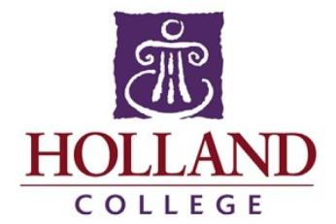

School of Visual Arts:
Fundamental Arts

Welcome to the Fundamental Arts program for 2021-2022!

The best way to prepare for the coming year is to draw every day. Just a quick sketch every day will keep your skills sharp.

Program Highlights:

- All materials and supplies are provided for you through your Lab Fee.

- Emphasis is placed on enhancing your drawing skills and learning the basics of design through exploration of a variety of mediums. You will also study art history and create an online portfolio.

- At the conclusion of the year you will have a strong portfolio to study further in the arts.

- Each year, Fundamental Arts students have some of their best work showcased at the School of Visual Arts gallery exhibition at the Confederation Centre of the Arts.

We are happy to be delivering this program in-person in 2021-22! That being said, we are complying with all public health measures issued by the Government of Prince Edward Island. Please be aware that students traveling from outside the province or country may be subject to self-isolation requirements or other restrictions. Any students affected by travel restrictions will be sent detailed information and instructions by the College’s First Year Advising team. Please be sure to read through all college communications carefully as the summer progresses.

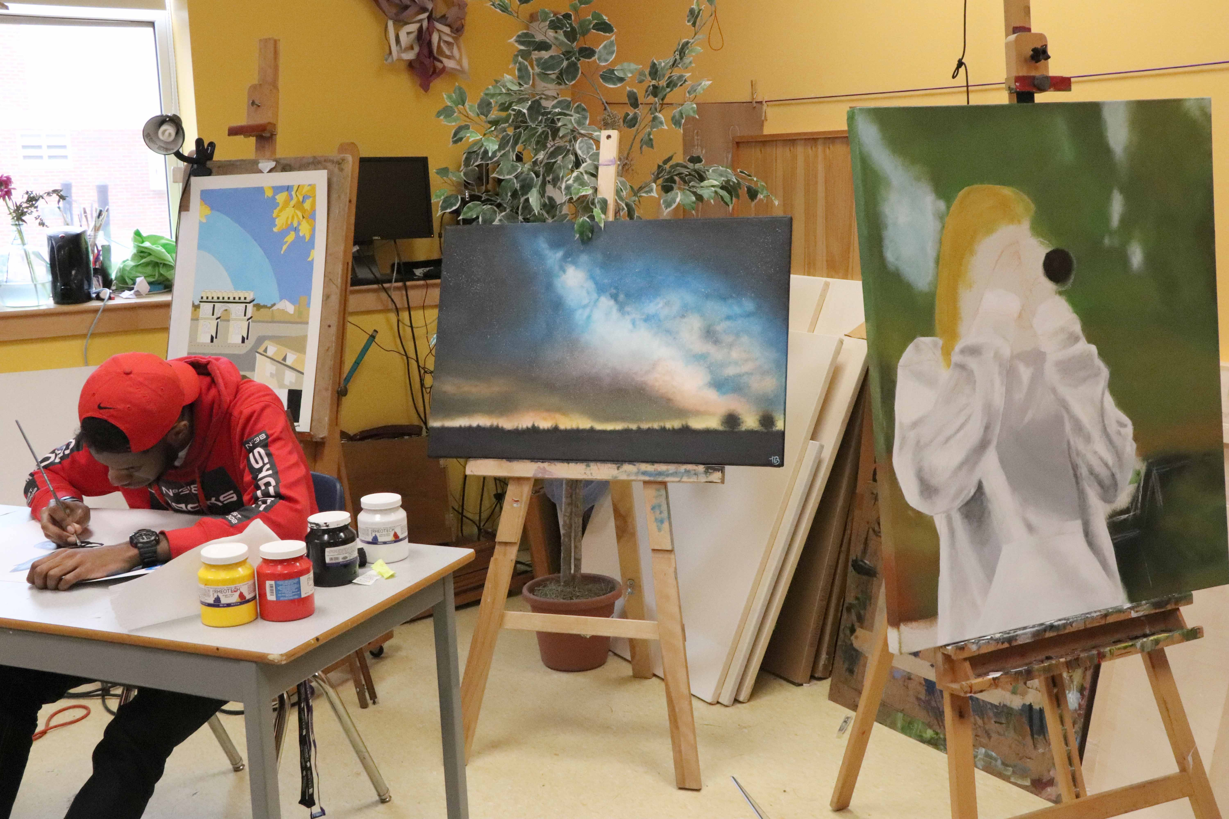

Important Dates:

Classes begin - September 1
Last day of classes before Christmas break - December 10
First day of classes in the new year - January 6
Spring break - February 22-28
Last day of class second semester - April 22

Location of classroom: Prince of Wales Campus
285 Kent Street
Charlottetown, P.E.I.
Charlottetown Centre room, 27C

We look forward to meeting you and working with you this coming school year. Have a great summer! Your instructor will be reaching out with more information in the coming weeks.

Liam Corcoran
Program Manager, School of Visual Arts
ldcorcoran@hollandcollege.com

