**HOLLAND COLLEGE ORDER FORM**

|  |  |  |  |  |
| --- | --- | --- | --- | --- |
| Item | Size | Male OR Female | Quantity | Price |
| Reflective Cargo Pants  **(47300EMS/47300WEMS)** |  |  |  | $81.50 |
| Hemming or Alterations  **(HEM)** |  |  |  | $5.00/pair |
| Short Sleeve White Shirt  **(82S/82FS)** |  |  |  | $31.50 |
| Long Sleeve White Shirt  **(82L/82FL)** |  |  |  | $33.00 |
| Holland College Crests (add 2 per shirt)  **CREST-0033** |  |  |  | $3.75/per |
| PCP Epaulets  **(NG-09081401-51-G)** |  |  |  | $16.00/pair |
| ACP Epaulets  **(NG-09081402-51G)** |  |  |  | $16.00/pair |
| Safety Kit  **(SAFETYKIT-HOLLAND)** |  |  |  | $119.00 |
| Job Shirt  **(CSW8881M)** |  | Unisex |  | $101.74 |
| Winter Jacket  **(71275)** |  | Unisex |  | $279.00 |

Pricing:

Short sleeve white button up shirt: (Oversize (19.5 & up) +10%, tall sizes +10%, Oversize & Tall +20%)

Long sleeve white button up shirts: (Oversize (19.5 & up) +10%, tall sizes +10%, Oversize & Tall +20%)

** For Sizing tips, see below

Shirts:

* The shirts are measured by neck size and are measured in inches. We have both long and short sleeve options.

|  |  |
| --- | --- |
| Female Shirts | Males Shirts |
| 12.5” (XS)  13.5" (S)  14.5" (M)  15.5" (L)  16.5” (XL)  17.5” (2XL)  18.5” (3XL) | 14.5" (S)  15.5" (M)  16.5" (L)  17.5” (XL)  18.5” (2XL)  19.5” (3XL)  20.5” (4XL)  ** Available in regular and tall sizes.  Reg. Sleeve Length: 34/35”  Tall Sleeve Length: 36/37” |

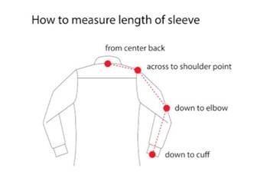

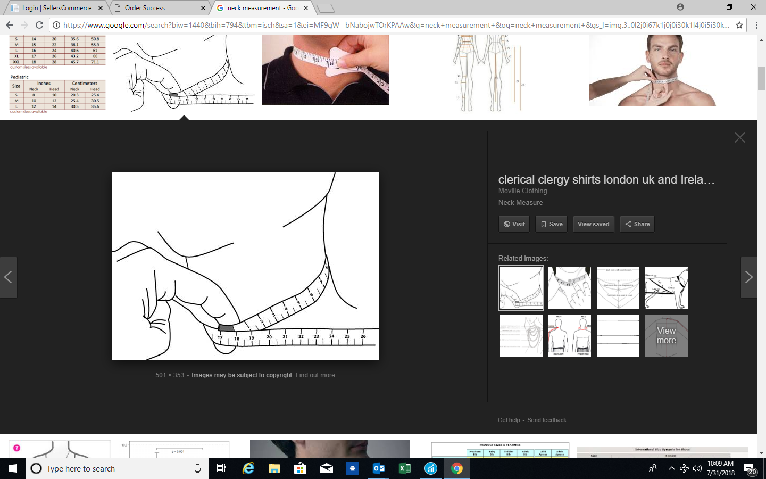

Pants:

* The pants will come striped with the reflective on the lower leg. I included the Flying Cross pant sizing chart. The pants come unhemmed, but we do offer in-house hemming for $10+tx a pair.

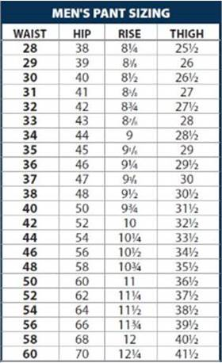

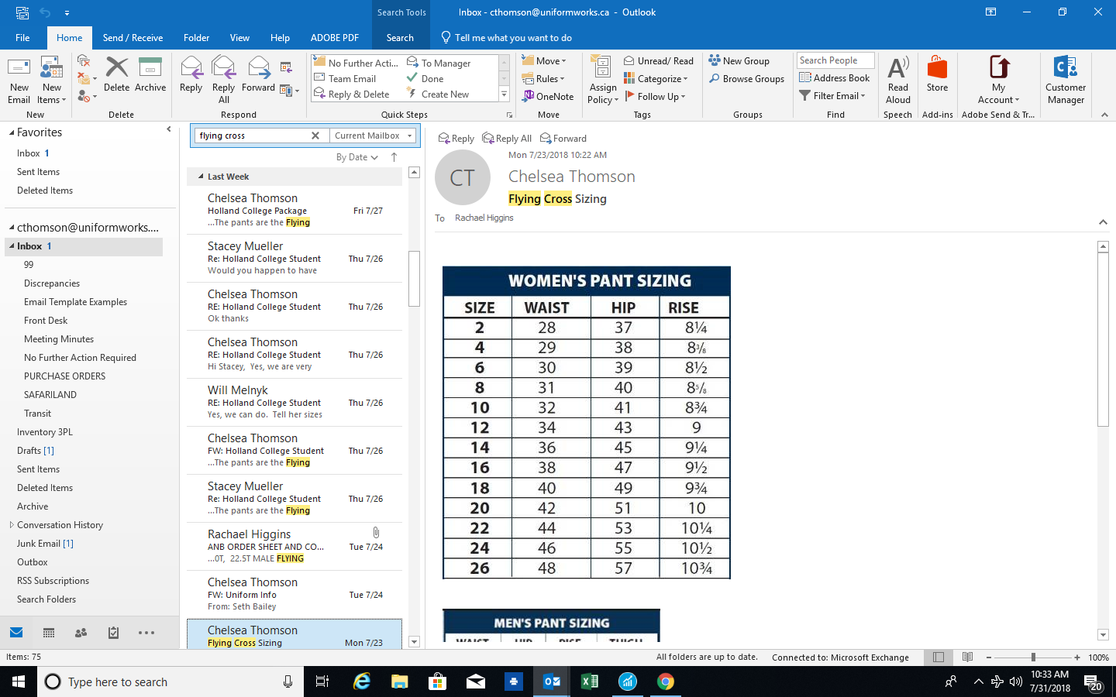

Safety Kit:

* The safety kit comes with a bag embroidered with Holland College, a safety vest, hard hat, two pairs of rubber gloves, a pair of work gloves, and a dust mask.

Job Shirt:

* The job shirt fits large and we like to suggest ordering a size larger than you would typically wear.

** If your order needs to be delivered, a **freight charge** will be applied based on your location.

** Prices are subject to change.

Contact:

Amie McLaughlin  
Customer Service Sales & Support Administrator - Uniform Works Limited

**amclaughlin@uniformworks.ca**

89 Cutler Avenue | Suite 105 | Dartmouth, NS  B3B 0J5  
T: (902) 468-5367 EXT#101 F: (902) 468-6056