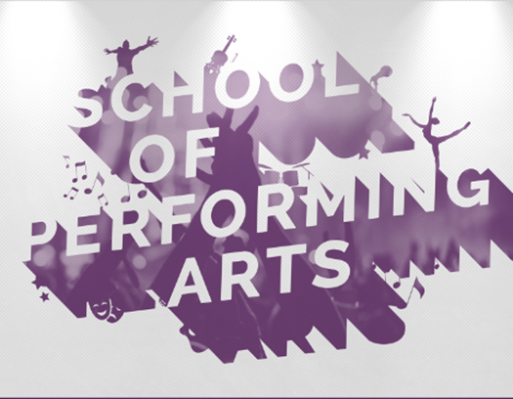

Hello and Welcome to all Holland College School of Performing Arts (SoPA) Music Performance students! We hope you are enjoying a great summer and we look forward to welcoming you in September. Please take a few minutes to read through this important information about your program!

IMPORTANT DATES
September 1: First-year students begin
December 10: Last day of Semester 1
January 6: First day of Semester 2
February 22-28: February Break (no classes)
April 22: Last day of Semester 2

ORIENTATION
During the week of September 1-3, the Music faculty will lead orientation activities to introduce you to college and program procedures. You will get a chance to meet your classmates and your instructors. Depending on government restrictions that may be in place at that time, there is a possibility that these orientation activities will happen virtually, but it’s too early to say. We will keep you informed over the summer as new information becomes available. Either way, we will get started on September 1!

WHAT TO BRING
The equipment you are required to bring with you will depend on your main instrument. Singers are required to bring their own microphone (SM-58 is
preferred). Guitarists, bassists, woodwind and string players are required to bring their own
instrument plus at least 2 quarter-inch cables. Drummers are required to bring their own assortment of sticks. Keyboard players are required to bring 2 quarter-inch instrument cables plus a sustain pedal. (You can feel free to buy equipment
at our local music store if you don’t want to travel with these things).

TECHNOLOGY
While you are not required to bring any special technology, you are welcome to bring your own laptop or tablet to use for your coursework where applicable.

TEXTBOOKS
Your textbooks will be available for purchase at our campus bookstore, which is located directly across the street from our main Music building. Your instructors will provide the list of textbooks needed once you arrive.

SUMMER ELECTIVES (Optional)
Anyone planning on attending Berklee College of Music after Holland College may want to consider taking an elective course this summer. This is completely optional, but if you were to take one of the Psychology courses being offered, you would get 3 credits toward your Holland College diploma AND your eventual degree at Berklee. Registration link is here: https://www.hollandcollege.com/programs/credit-courses.php

CONTACT INFORMATION
If you have any questions about the program, please contact Liam Corcoran via email at any time.
Email: ldcorcoran@hollandcollege.com

Check us out on social media!
https://www.facebook.com/HCSoPA
@sopa_hollandcollege

